Pivotal Notes:
Sticky Sessions: when multiple instances of an application are running on CF, requests from a particular client always reach the same application instance. This allows applications to store session data specific to a user session.
To support sticky sessions, applications must return a JSESSIONID cookie in responses.
If an application returns a JSESSIONID cookie to a client request, the CF routing tier appends a second cookie, called VCAP_ID , containing a
unique identifier for the application instance. On subsequent requests, the client must provide both the JSESSIONID and VCAP_ID cookies. The
CF routing tier uses the VCAP_ID to forward client requests to the same application instance every time.

CF does not persist or replicate HTTP session data across application instances. If an instance of an application crashes or is
stopped, session data for that instance is lost. If you require session data to persist across crashed or stopped instances, or to be shared
by all instances of an application, store session data in a CF marketplace service that offers data persistence.

The CF router uses the round-robin algorithm for load balancing incoming requests to application instances. The router maintains a dynamically updated list of application instances for each route, and forwards each request for a given route to the next application instance in the list.

Diego Architecture:
Cloud Foundry has used two architectures for managing application containers: Droplet Execution Agents  (DEA) and Diego. With the DEA
architecture, the Cloud Controller  schedules and manages applications on the DEA nodes. In the newer Diego architecture, Diego
components replace the DEAs and the Health Manager (HM9000), and assume application scheduling and management responsibility from the
Cloud Controller.

1. The Cloud Controller passes requests to stage and run applications to the Cloud Controller Bridge (CC-Bridge).
2. The CC-Bridge translates staging and running requests into Tasks
3. The BBS submits the Tasks and LRPs to the Auctioneer, part of the Diego Brain.
4. The Auctioneer distributes these Tasks and LRPs to Cells through an Auction.
5. Once the Auctioneer assigns a Task or LRP to a Cell, an in-process E xecutor creates a Garden container in the Cell. The Task or LRP
runs in the container.
6. The BBS tracks desired LRPs, running LRP instances, and in-flight Tasks. It also periodically analyzes this information and corrects
discrepancies to ensure consistency between ActualLRP and DesiredLRP counts.
7. The Metron Agent, part of the Cell, forwards application logs, errors, and metrics to the Cloud Foundry Loggregator.

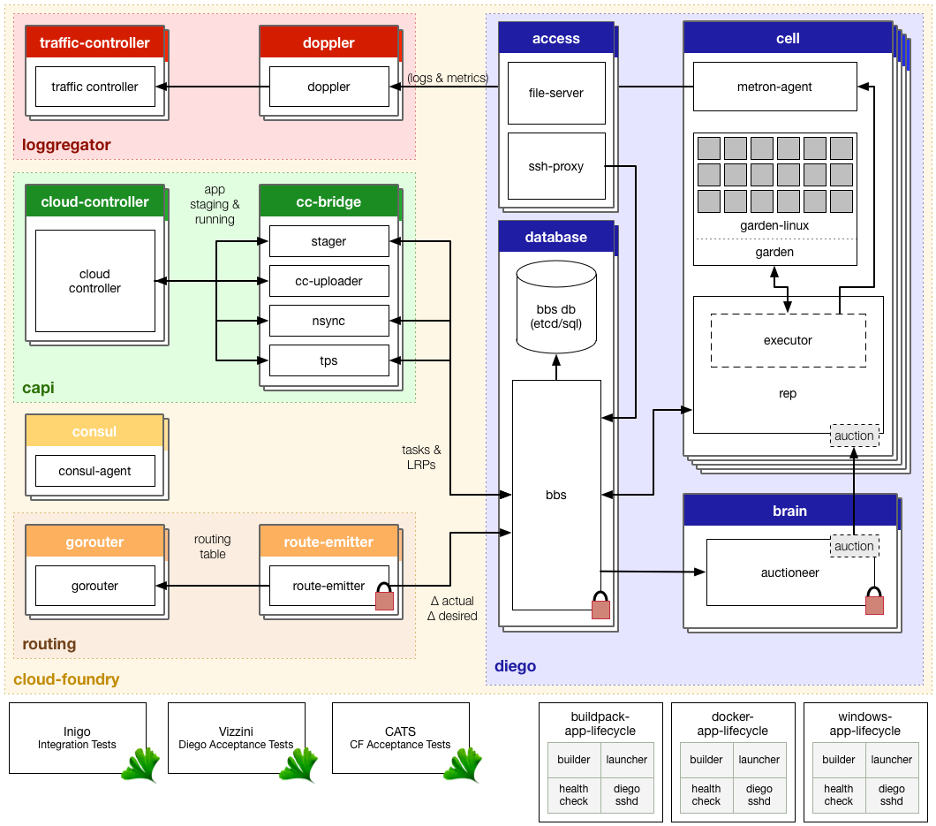Diego Core Components:
Brain
Cells
Database VMs
Access VMs
Consul

Diego Brain
Diego Brain components distribute Tasks and LRPs to Diego Cells, and correct discrepancies between ActualLRP and DesiredLRP counts to
ensure fault-tolerance and long-term consistency. The Diego Brain consists of the Auctioneer.
Auctioneer:
Uses the auction package  to run Diego Auctions for Tasks and LRPs
Communicates with Cell Reps over HTTP
Maintains a lock in the BBS that restricts auctions to one Auctioneer at a time

Diego Cell Components:
Diego Cell components manage and maintain Tasks and LRPs.
Rep
Represents a Cell in Diego Auctions for Tasks and LRPs
Mediates all communication between the Cell and the BBS
Ensures synchronization between the set of Tasks and LRPs in the BBS with the containers present on the Cell
Maintains the presence of the Cell in the BBS
Runs Tasks and LRPs by asking the in-process Executor to create a container and RunAction recipes

Executor:
Runs as a logical process inside the Rep
Implements the generic Executor actions detailed in the API documentation 
Streams STDOUT and STDERR to the Metron agent running on the Cell
Garden
Provides a platform-independent server and clients to manage Garden containers
Defines the garden-linux  interface for container implementation
Metron Agent
Forwards application logs, errors, and application and Diego metrics to the Loggregator  Doppler component

Database VMs:
Diego Bulletin Board System:
Maintains a real-time representation of the state of the Diego cluster, including all desired LRPs, running LRP instances, and in-flight Tasks
Provides an RPC-style API over HTTP to Diego Core components and external clients, including the SSH Proxy, CC-Bridge, and Route
Emitter.
Ensure consistency and fault tolerance for Tasks and LRPs by comparing desired state (stored in the database) with actual state (from
running instances)
Acts to keep DesiredLRP count and ActualLRP count synchronized in the following ways:
If the DesiredLRP count exceeds the ActualLRP count, requests a start auction from the Auctioneer
If the ActualLRP count exceeds the DesiredLRP count, sends a stop
Monitors for potentially missed messages, resending them if necessary.

Etcd:
Provides a consistent key-value data store to Diego.
Access VMs:
File Server
This “blobstore” serves static assets that can include general-purpose App Lifecycle binaries and application-specific droplets and build
artifacts.

SSH Proxy
Brokers connections between SSH clients and SSH servers running inside instance containers
Consul
Provides dynamic service registration and load balancing through DNS resolution
Provides a consistent key-value store for maintenance of distributed locks and component presence

Cloud Controller Bridge Components:
The Cloud Controller Bridge (CC-Bridge) components translate app-specific requests from the Cloud Controller to the BBS. These components
include the following:
Stager
Translates staging requests from the Cloud Controller into generic Tasks and LRPs
Sends a response to the Cloud Controller when a Task completes
Refer to the Stager repo  on GitHub for more information.
CC-Uploader
Mediates uploads from the Executor to the Cloud Controller
Translates simple HTTP POST requests from the Executor into complex multipart-form uploads for the Cloud Controller
Refer to the CC-Uploader repo  on GitHub for more information.
Nsync
Listens for app requests to update the DesiredLRPs count and updates DesiredLRPs through the BBS
Periodically polls the Cloud Controller for each app to ensure that Diego maintains accurate DesiredLRPs counts
Refer to the Nsync repo  on GitHub for more information.
TPS
Provides the Cloud Controller with information about currently running LRPs to respond to cf apps and cf app APP_NAME requests
Monitors ActualLRP activity for crashes and reports them the Cloud Controller

CF Routes:
routes - List all routes in the current space or the current organization
USAGE: cf routes [--orglevel]
ALIAS: r
OPTIONS:
--orglevel List all the routes for all spaces of current organization

NAME:
create-route - Create a url route in a space for later use

EXAMPLES:
cf create-route my-space example.com # example.com
cf create-route my-space example.com --hostname myapp # myapp.example.com
cf create-route my-space example.com --hostname myapp --path foo # myapp.example.com/foo
cf create-route my-space example.com --port 50000 # example.com:50000

OPTIONS:
--hostname, -n Hostname for the HTTP route (required for shared domains)
--path Path for the HTTP route
--port Port for the TCP route
--random-port Create a random port for the TCP route

NAME:
map-route - Add a url route to an app

USAGE:
Map an HTTP route:
cf map-route APP_NAME DOMAIN [--hostname HOSTNAME] [--path PATH]

Map a TCP route:
cf map-route APP_NAME DOMAIN (--port PORT | --random-port)

EXAMPLES:
cf map-route my-app example.com # example.com
cf map-route my-app example.com --hostname myhost # myhost.example.com
cf map-route my-app example.com --hostname myhost --path foo # myhost.example.com/foo
cf map-route my-app example.com --port 50000 # example.com:50000

OPTIONS:
--hostname, -n Hostname for the HTTP route (required for shared domains)
--path Path for the HTTP route
--port Port for the TCP route
--random-port Create a random port for the TCP route

NAME:
unmap-route - Remove a url route from an app

USAGE:
Unmap an HTTP route:
cf unmap-route APP_NAME DOMAIN [--hostname HOSTNAME] [--path PATH]

Unmap a TCP route:
cf unmap-route APP_NAME DOMAIN --port PORT

EXAMPLES:
cf unmap-route my-app example.com # example.com
cf unmap-route my-app example.com --hostname myhost # myhost.example.com
cf unmap-route my-app example.com --hostname myhost --path foo # myhost.example.com/foo
cf unmap-route my-app example.com --port 5000 # example.com:5000

OPTIONS:
--hostname, -n Hostname used to identify the HTTP route
--path Path used to identify the HTTP route
--port Port used to identify the TCP route

NAME:
delete-route - Delete a route

USAGE:
Delete an HTTP route:
cf delete-route DOMAIN [--hostname HOSTNAME] [--path PATH] [-f]

Delete a TCP route:
cf delete-route DOMAIN --port PORT [-f]

EXAMPLES:
cf delete-route example.com # example.com
cf delete-route example.com --hostname myhost # myhost.example.com
cf delete-route example.com --hostname myhost --path foo # myhost.example.com/foo
cf delete-route example.com --port 50000 # example.com:50000

OPTIONS:
-f Force deletion without confirmation
--hostname, -n Hostname used to identify the HTTP route
--path Path used to identify the HTTP route
--port Port used to identify the TCP route

NAME:
delete-orphaned-routes - Delete all orphaned routes (i.e. those that are not mapped to an app)

USAGE:
cf delete-orphaned-routes [-f]

OPTIONS:
-f Force deletion without confirmation

CF Domains:
- domains - List domains in the target org
USAGE: cf domains
- create-domain - Create a domain in an org for later use
USAGE: cf create-domain ORG DOMAIN
- delete-domain - Create a domain in an org for later use
Usage: cf delete-domain DOMAIN [-f]
- create-shared-domain- Create a domain that can be used by all orgs (admin-only)
USAGE:
cf create-shared-domain DOMAIN [--router-group ROUTER_GROUP]
OPTIONS:
--router-group Routes for this domain will be configured only on the specified router group
5. delete-shared-domain - Delete a shared domain
USAGE:
cf delete-shared-domain DOMAIN [-f]
OPTIONS:
-f Force deletion without confirmation

BLUE – GREEN Deployment
Blue-green deployment is an approach to upgrading applications with minimal downtime
- It also enables easy rollback to the old version if the new version experiences problems
- It works by keeping both versions online, and switching from the old version to the new version
- Blue-green deployment is an approach to upgrading applications with minimal downtime
- It also enables easy rollback to the old version if the new version experiences problems
- It works by keeping both versions online, and switching from the old version to the new version

Cloud Foundry Services
A service is an external application dependency or component such as:
– External state
• Database, cache, message queue
– Tools
• Monitoring app, external logging sink, OAuth security
– External applications
• Microservice, web service, legacy application

Two Types of Services:
• Managed services (“marketplace” services)
– Available from the marketplace 'catalog'
– Instances are often provisioned and managed by the platform, for use by applications
– The platform supplies connection information to applications
– Can be custom created
• User provided services
– The service is not in the marketplace
– The platform only supplies connection information to applications

Cf command:
- marketplace - List available offerings in the marketplace
ALIAS: m
OPTIONS:
-s Show plan details for a particular service offering

Get the service plans of service:
- cf marketplace –s <service name>

- services - List all service instances in the target space
USAGE: cf services
ALIAS:s
- create-service - Create a service instance
USAGE:
cf create-service SERVICE PLAN SERVICE_INSTANCE [-c PARAMETERS_AS_JSON] [-t TAGS]
Optionally provide service-specific configuration parameters in a valid JSON object in-line:

cf create-service SERVICE PLAN SERVICE_INSTANCE -c '{"name":"value","name":"value"}'

Optionally provide a file containing service-specific configuration parameters in a valid JSON object.
The path to the parameters file can be an absolute or relative path to a file:

cf create-service SERVICE PLAN SERVICE_INSTANCE -c PATH_TO_FILE

Example of valid JSON object:
{
"cluster_nodes": {
"count": 5,
"memory_mb": 1024
}
}

- bind-service - Bind a service instance to an app
USAGE:
cf bind-service APP_NAME SERVICE_INSTANCE [-c PARAMETERS_AS_JSON]

Optionally provide service-specific configuration parameters in a valid JSON object in-line:

cf bind-service APP_NAME SERVICE_INSTANCE -c '{"name":"value","name":"value"}'

- Bind service to the app instance using manifest file
---
applications:
- name: myapp
memory: 128M
services:
- myservice

Using a Managed Service – Developer View
Create a service instance for the space (if necessary)
• Bind it to your application
• Modify your application to read configuration information via environment variables (if necessary)
The platform creates user accounts and passwords for service instances
– No need to hard-code any connection information
• After binding a service instance, connection information is available to applications in environment variables:
VCAP_SERVICES
• Once the application is staged, view connection
information using
– cf env [app-name]
– Look for VCAP_SERVICES in the output

User Provided Service Instances
Typically represent external assets like legacy databases
• Behave like other service instances once created
• When bound, they provide service instance credentials
and other configuration information to applications
– Avoids hard coding service instance endpoints

- create-user-provided-service - Make a user-provided service instance available to CF apps
USAGE:
cf create-user-provided-service SERVICE_INSTANCE [-p CREDENTIALS] [-l SYSLOG_DRAIN_URL] [-r ROUTE_SERVICE_URL]

Pass comma separated credential parameter names to enable interactive mode:
cf create-user-provided-service SERVICE_INSTANCE -p "comma, separated, parameter, names"

Pass credential parameters as JSON to create a service non-interactively:
cf create-user-provided-service SERVICE_INSTANCE -p '{"key1":"value1","key2":"value2"}'

Specify a path to a file containing JSON:
cf create-user-provided-service SERVICE_INSTANCE -p PATH_TO_FILE
{
user-provided: [
{
name: "mydb",
label: "user-provided",
tags: [ ],
credentials: {
hostname: "db.example.com",
port: "1234",
username: "dbuser",
password: "dbpasswd",
name: "mydb"
}
}
]
}

Elastic Runtime
- The Elastic Runtime is about managing distributed applications in containers.
- BOSH/Ops Manager is about managing distributed software on VM clusters
- The Elastic Runtime is an example of the distributed software that BOSH can manage
- The Elastic Runtime is a set of components/VMs used to run highly available, scalable applications in containers

the Elastic Runtime have three main states
– Staging
– Starting
– Running

Staging
• cf push starts the process of staging the application
• Staging is done in one of the containers in a Cell
• Staging prepares the application to be quickly deployed and scaled on the platform
• The goal of staging is to produce a droplet…

Droplet
• During staging, a buildpack takes all of the bits related to the application and produces a droplet – A droplet is an archived file such as a tarball
• The droplet is stored in the Elastic Runtime's blobstore
• The staging container is then destroyed

Starting
• Once the application is staged, it can be started
• Starting is part of cf push by default
• A droplet is copied from the blobstore into each container
• Very fast process – application instances can be scaled very quickly

Router
• Once the application is started, the router can route traffic to it
• The Cloud Controller is not involved in application requests

Running- Health Management
• Once an application is running, it is continuously being monitored
– If an application instance dies, it is recreated
– If an entire Cell or DEA dies, application instances are redistributed to other
Cells/DEAs
• Pre Diego: the health manager performed this function
• Diego: this function is incorporated into the Brain

Application Security Groups

• Application Security Groups enable application containers to be locked down to only necessary
outbound connections
• By default, outbound traffic from application containers is not locked down
• Can set rules to enable access to only certain IP addresses and/or protocols
– Acts as a virtual firewall
– Especially useful for highly regulated industries (financial services, government, healthcare, etc.)
• The application containers are locked down by operators and the security rules are viewable by developers

Commands related to securities group:
- security-group - Show a single security group
Usage- cf security-group SECURITY_GROUP
- security-groups - List all security groups
Usage: cf security-groups
- create-security-group - Create a security group
Usage:
cf create-security-group SECURITY_GROUP PATH_TO_JSON_RULES_FILE

The provided path can be an absolute or relative path to a file. The file should have
a single array with JSON objects inside describing the rules. The JSON Base Object is
omitted and only the square brackets and associated child object are required in the file.

Valid json file example:
[
{
"protocol": "tcp",
"destination": "10.244.1.18",
"ports": "3306"
}
]
- update-security-group - Update a security group
Usage:
cf update-security-group SECURITY_GROUP PATH_TO_JSON_RULES_FILE
The provided path can be an absolute or relative path to a file.
It should have a single array with JSON objects inside describing the rules.
TIP: Changes will not apply to existing running applications until they are restarted.
- delete-security-group - Deletes a security group
Usage:
cf delete-security-group SECURITY_GROUP [-f]
OPTIONS:
-f Force deletion without confirmation

6. bind-security-group - Bind a security group to a particular space, or all existing spaces of
an org
USAGE:
cf bind-security-group SECURITY_GROUP ORG [SPACE]
TIP: Changes will not apply to existing running applications until they are restarted.
- unbind-security-group - Unbind a security group from a space
Usage: cf unbind-security-group SECURITY_GROUP ORG SPACE

TIP: Changes will not apply to existing running applications until they are restarted

- bind-staging-security-group - Bind a security group to the list of security groups to be used for staging applications
USAGE:
cf bind-staging-security-group SECURITY_GROUP
- staging-security-groups - List security groups in the staging set for applications
USAGE:
cf staging-security-groups
- unbind-staging-security-group - Unbind a security group from the set of security groups for staging applications
USAGE:
cf unbind-staging-security-group SECURITY_GROUP
- bind-running-security-group - Bind a security group to the list of security groups to be used for running applications
USAGE:
cf bind-running-security-group SECURITY_GROUP
- running-security-groups - List security groups in the set of security groups for running applications
USAGE:
cf running-security-groups

Logging and Metrics in Cloud Foundry
Loggregator-
• Provides logging and metrics for the Elastic Runtime
• A modern approach to logging that emphasizes:
– Support for ephemeral, container-based applications
– Productivity by streaming logs and metrics to operators and developers (no log shipping)
– Accessibility and visibility into your applications and the platform
– Seamless integration with modern log management services (e.g. Splunk, LogStash)

cf logs <app_name> --recent

• A component of the Loggregator system called the Traffic Controller receives and responds to requests for logs and metrics
• Note: Loggregator typically sends logging traffic out over port 4443- your company’s inbound firewall must open this port in order to read logs using cf logs
– This port is configured in Ops Manager > Pivotal Elastic Runtime > Settings > IPs and Ports > Loggregator port

Scaling Logging and Metrics Data Handling
• Doppler Servers and Traffic Controllers are components of the Loggregator system installed with
Pivotal Elastic Runtime
• The components may become lossy if the logging and metric data is too high (e.g. large number
of Cells or apps)
– The system favors stability over logging everything
• Scale these components using the Resource Config tab of Pivotal Elastic Runtime
• You can also increase the Syslog Drain Buffer size on the System Logging tab (default is 100
messages)

Syslog Drains
• Syslog drains allow data related to an application to be sent to thirdparty log
managers
• The data from the Doppler Servers is sent to the Syslog drain
– The Traffic Controller is not used

Firehose and Nozzles
• Traffic Controllers have a Firehose endpoint
• The Firehose streams all the event data coming from an Elastic Runtime deployment
– Includes application logs, HTTP events and container metrics
– Includes metrics from all Elastic Runtime components
– Does not include Elastic Runtime component logs
• Operators can deploy nozzles to the Firehose endpoint, which listen for a subset of data
from the Firehose

Application Performance Monitoring (APM) Integration
• APM is for real-time monitoring of applications
• Used to find and fix performance problems
– An agent in the application container monitors down to the line of code
– Can include client-side performance
• Examples:
– New Relic
– AppDynamics

Pushing, Staging, Restarting
• When you turn on APM for an existing application, the PHP and Java buildpacks add the agent
when creating the droplet
• This means that restarting the application will not turn on APM
– cf push uploads files and creates a droplet, optionally starts the app
– cf restage creates a droplet
– cf restart creates new app instances from the existing droplet- will not create a new
droplet

cf-command
cf create-service newrelic standard apm
cf bind-service your-app apm

Cloud Controller API
• The Cloud Controller API is used to:
– obtain information about the platform
– make changes to the platform
• Calls from clients and scripts, including custom ones, often include Cloud
Controller API calls
• Logs often contain results of the API calls and help with troubleshooting
• When you set a target, you are connecting to a component of Cloud Foundry called the
Cloud Controller
• The Cloud Controller has a REST API
• The commands of the cf CLI and other clients like Apps Manager directly call this API
• You can also call this API directly

Service Brokers

OAuth Primer

Why an OAuth Primer?
• Securing the Cloud Foundry platform and applications includes OAuth
• OAuth demonstrates a modern approach to securing highly distributed cloud-native
Applications
• Authentication- Verifies the credentials of a user
• Authorization- Verifies that connection from an authenticated user to a resource is
Allowed

OAuth 2.0
• Open standard framework for delegated resource authorization
– http://oauth.net
– Flexible enough to handle many implementations and authorization flows
• Designed for distributed systems
• Allows third-party delegated access to secure resources via access tokens, not by
Sharing user credentials

.

